Kildare County Council

Statement to accompany Part 8 Public Consultation

Kildangan Railway Bridge Footpath Scheme – Reference P82017.011

August 2017

Kildare County Council
Roads, Transportation and Public Safety
Level 4, Áras Chill Dara
Devoy Park
Naas, Co. Kildare

Contents

- Description of the proposed development.______________________________3

- Consistency with the proper planning and sustainable development of the area and the County Development Plan._____________________________________5

- Scheme Justification.________________________________________________7

- Impact of the proposed scheme._______________________________________7

- Pre-Part 8 Consultations.____________________________________________10

- Appropriate Assessment – Stage 1 Screening & Flood Risk Assessment_______________________________________________________11

- Part 8 Consultations._______________________________________________12

Appendix A_______________________________________________________15
The following is a report prepared in accordance with Part 8 of the Planning and Development Regulations, 2001 (as amended) providing information in relation to the provision of a new pedestrian footpath across the railway bridge in Kildangan Village and ancillary works.

Description of the proposed development
Kildare County Council’s Roads, Transportation and Public Safety Department proposes to provide a new footpath across the railway bridge in Kildangan Village and to carry out ancillary works which will greatly improve road safety for pedestrians and other vulnerable road users in the village. Upgrades of the existing footpaths and public lighting, to the east and west of the proposed scheme, will be carried out as part of the maintenance and repair works scheduled to be carried out by the Athy Municipal District Area Office at this location.
The scheme will include the following elements:
- Provision of a footpath and public lighting across the northern side of the railway bridge in Kildangan to tie-in with existing footpaths at both ends of the railway bridge.

- Provision of a protective kerb along the carriageway on the southern side of the railway bridge.

- Provision of pedestrian crossings at both ends of the railway bridge to tie-in with the existing footpaths.

- Installation of powder coated steel parapets above both existing bridge parapets and approach walls in compliance with the requirements of Iarnród Éireann / CIE.

- Provision of traffic signals on the approach to the railway bridge to establish a one-way shuttle traffic system across the railway bridge on the L3010.

- Provision of traffic signals to facilitate egress from the private entrances within the one-way shuttle traffic system.

- Erection of CCTV and red light violation cameras at the railway bridge as per Kildare County Council Specification for Bridge Shuttle Systems.

- Road signage and road markings related to the above.

- Ancillary works related to above.

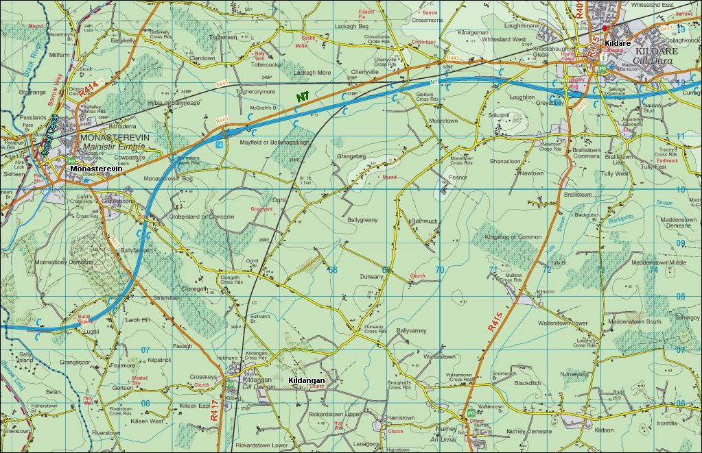
Site Location
Fig. 1 Site Location

Fig. 2 Scheme Extents

Consistency with the proper planning and sustainable development of the area and the County Development Plan
Kildangan is located in southwest Kildare, close to the border with County Laois and to the south of Monasterevin town. Kildangan is designated as a ‘Village’ in the County Settlement Strategy set out in Chapter 2 of the Kildare County Development Plan 2017-2023.
The village is located 5km from Monasterevin, 10km from Kildare Town and 14km north of Athy and is situated on the R417 Monasterevin to Athy regional route. The Kildare Town to Athy railway line runs through the centre of the village.
The proposed development is in compliance with the goals, policies and objectives of the Kildare County Development Plan 2017-2023. In particular the following policy objectives which are set out in the following sections:
Volume 1 – Chapter 6 – Movement and Transport

Section 6.5 Policies: Walking and Cycling

WC 2: Promote the development of safe and convenient walking and cycling routes.

WC 3: Ensure that connectivity for pedestrians and cyclists is maximised in new communities and improved within the existing areas in order to maximise access to town centres, local shops, schools, public transport services and other amenities.

WC 7: Provide for safer routes to schools within the county and to promote walking and cycling as suitable modes of transport as part of the
Green Schools Programme and other local traffic management improvements.

Section 6.5 Objectives: Walking and Cycling

WCO 3: Carry out local traffic management improvements to provide safer routes to schools in order to encourage students, where possible, to walk and cycle as a sustainable alternative to the car. These improvements may be carried out in conjunction with the NTA, through the Sustainable Transport Management Grants Scheme.

Table 6.1 – Priority Road and Bridge Projects
This table in the Kildare County Development Plan 2017-2023 includes ‘Improvements to Kildangan Bridge’.

Volume 2 - Chapter 2 – Village Plans and Settlements

Section 2.5.9 Kildangan Village Plan
2.5.9.8 Transportation
Kildangan is located on the R417 which allows for excellent access to Monasterevin and the M7 motorway to the north and Athy town to the south. Kildangan is only a short distance from Monasterevin. No major new road development is required in the area, however, various upgrading works will be required in tandem with development in the village.
2.5.9.12 Development Objectives

Residential Development Objectives

In order to facilitate local demands and in recognition of the level of development that has taken place in the recent past, future residential development should be undertaken in conjunction with appropriate social and commercial development. An area of 6.1ha has been identified for residential development.

It is an objective of the Council to:

RD1 Require those lands zoned ‘C’ (New Residential) on Map V2-2 to display:

- Improvements in pedestrian and cycling facilities back to the village centre as part of development proposals.

Transportation Objectives

T4 Improve the quality, aesthetics and width, where appropriate, of all footpaths in the village and improve access for people with disabilities.

T5 Realign and improve all regional and local roads in the village and on the approaches to the village. Improvements shall include realignment, widening, where appropriate, pedestrian facilities, drainage, public lighting and traffic calming where necessary.

T6 Investigate the possibility of realigning the road, in co-operation with Iarnród Éireann, between Kildangan Manor and the village centre, and to make the railway bridge pedestrian friendly.

Conclusion
The proposed development is consistent with the proper planning and sustainable development of the area, in that:
- It will provide a safe means of access for pedestrians and vulnerable road users, including school children crossing the railway bridge which currently has no footpath.

- It will improve pedestrian access to both sides of the village which is bisected by the railway bridge and in particular pedestrian access to and from residential developments, the village hall, the primary school, church and shops.

- It will reduce traffic speeds and improve road safety in the vicinity of the railway bridge due to the establishment of a one-way shuttle traffic system which will be controlled by traffic signals and monitored by CCTV.

- It will improve road safety and security for pedestrians and vulnerable road users due to the provision of public lighting over the railway bridge and along the L3010.

Scheme justification
Development in Kildangan has been carried out on both sides of the railway line which bisects the village. The absence of a footpath over the railway bridge and the provision of safe access for pedestrians to both sides of the village and in particular the national school, the church, the village hall and retail facilities is limiting free access for pedestrians throughout the village. There are also ongoing issues around possible conflicts between vehicular traffic and vulnerable road users traversing the railway bridge in the absence of a dedicated footpath, pedestrian crossing facilities and public lighting.
This scheme will fully address these issues by enhancing the road environment in the vicinity of the railway bridge.

Impact of the proposed scheme
Impact on Traffic
The construction of a new footpath, an associated reduction in the carriageway width and the establishment of a one-way shuttle traffic system will result in reduced traffic speeds on the approaches to the railway bridge and across the railway bridge. A traffic count taken in February 2017 at Duneany recorded an Annual Average Daily Traffic (AADT) figure of 2289 vehicles on the L3010. This work will also facilitate safer controlled access to and from a number of properties with domestic and farm entrances located within the bounds of the railway bridge.
Although it is envisaged that this scheme will have some minor impact on traffic during construction, no long term negative impacts are expected in relation to traffic flows within Kildangan Village.

Impact on pedestrians and vulnerable road users
The proposed works will have a significantly positive impact on pedestrians and vulnerable road users seeking to traverse the railway bridge in Kildangan Village. The provision of the following improvements will greatly enhance pedestrian access, movement and safety within the village.
- A new footpath shall be constructed along the northern side of the railway bridge with a corresponding concrete rubbing strip along the southern side. The absolute minimum width of the footpath will be 1.2m at the most narrow point which is located to the east of the bridge structure. The existing overall carriageway width within the scheme varies from 5.8m to 6.6m. The width of the proposed footpath will be increased where on site conditions allow with the majority of the footpath measuring 1.6m. The one-way shuttle traffic system will operate along a width of carriageway of 4.0m.
- It is proposed to install steel mesh panels, or similar approved, above the bridge capping stone of to achieve an overall parapet height of 1.8m. These panels will be flush with the inside face of the existing parapets, along the northern and southern bridge parapets, to comply with the requirements of Iarnród Éireann and CIE.
- A traffic signal controlled pedestrian crossing with tactile paving, which will tie-in to existing footpaths, is proposed on both approaches to the railway bridge. Footpaths on the Crosskeys side to the west and on the Kildangan Church end to the east are due to be upgraded by the Athy Municipal District Office.
- It is proposed to improve public lighting, road signage and road markings within the extent of the scheme. (Road number L3010).
Impact during construction
The following impacts during construction will be temporary:
- Site mobilisation and operations
- Temporary traffic management
- Construction traffic and materials deliveries
- Construction dust and noise
- Temporary hoarding/fencing/barriers/traffic cones
- Temporary site lighting, if deemed necessary
- Night works when necessary to cater for any works over the railway track.
Impact on landscape and visual amenity
All works will be taking place within the existing road corridor. A reduction in carriageway width and the provision of a footpath will address the current disparity in the use of the railway bridge by pedestrians and vehicular traffic. Improved public lighting, road signage and road markings in the vicinity of the works will also enhance and improve the existing streetscape at the works location.
The proposed construction of a footpath on the northern side of the railway bridge and a rubbing strip along the southern side will reduce the height of the existing stone parapet. As a consequence, and in order to comply strictly with the safety requirements of Iarnrod Eireann / CIE, it will be necessary to increase the parapet height over the operating rail track to a height of 1.8m above finished footpath level. It will also be necessary to increase the parapet height along the approach walls. An overall parapet height of 1.2m will be provided above the finished footpath level.
Impact on ecology
The proposed works do not lie within or affect any existing ecologically sensitive areas. As the works will be taking place within the existing road corridor there will be no ecological impact.
Impact on built and cultural heritage
The following information sources were checked as part of a desktop exercise to check for possible impact on built and cultural heritage:
- The National Monuments Service Sites and Monuments Record (SMR) – Nothing recorded in the vicinity of the proposed works.

- The National Inventory of Architectural Heritage (NIAH) – Nothing recorded in the vicinity of the proposed works.

- The Record of Monuments and Places (RMP) – Appendix 2 of the County Kildare Development Plan 2017-2023 - Nothing recorded in the vicinity of the proposed works.

- The Record of Protected Structures (RPS) for County Kildare – Appendix 3 of the County Kildare Development Plan 2017-2023 – Nothing recorded in the vicinity of the proposed works.
It was determined that the works will not impinge on or affect any built and cultural heritage.
Conclusion
It is expected that the proposed development will have some short-term negative impacts during construction but no longer-term impacts requiring mitigation are expected to arise.

Pre-Part 8 Consultations

Pre-Part 8 consultations were undertaken with the following key stakeholders:
Kildare County Council

  - Roads, Transportation & Public Safety Department.

  - Planning Department.

  - Conservation Officer, Planning Department.

  - Heritage Officer, Planning Department

  - Water Services Department

  - Environment Department

  - Fire Services.

  - Health and Safety Department.

  - Architect’s Department.

  - Community and Culture Department.

Athy Municipal District Elected Members

A Pre-Part 8 consultation took place with the Athy Municipal District Elected Members prior to the Municipal District Meeting held on the 24th July 2017. All of the Municipal District Elected Members listed below were in attendance.

  - Councillor Aoife Breslin

  - Councillor Mark Dalton

  - Councillor Ivan Keatley

  - Councillor Thomas Redmond

  - Councillor Martin Miley Jnr

  - Councillor Mark Wall

Iarnród Éireann / CIE.
Pre-Part 8 consultations have taken place with the Senior Track & Structures Engineer of Irish Rail. Appendix A includes a letter from Iarnrod Eireann Infrastructure, dated 21st July 2017, which indicates Iarnród Éireann and CIE has no objection to Kildare County Council proceeding with a Part 8 application subject to Kildare County Council entering into an agreement prior to work commencing.

Appropriate Assessment - Stage 1 Screening

Stage 1 Screening was carried out in accordance with Article 6(3) and 6(4) of the Habitats Directive (Council Directive 92/43/EEC of 21 May 1992 on the Conservation of natural habitats and of wild fauna and flora).

This is transposed in Ireland primarily by the European Communities (Birds and Natural Habitats) Regulations 2011 (S.I. No. 477/2011) (hereafter the Birds and Habitats Regulations) and the Planning and Development (Amendment) Act, 2010 as amended.

An Appropriate Assessment (AA) is required if likely significant effects on European Sites arising from the proposed development cannot be ruled out at the screening stage, either alone or in combination with other plans or projects.

Following an examination and evaluation of the relevant information, including in particular, the fact that the proposed works will not impinge or impact on any European Sites, it is possible to rule out likely significant effects on all European Sites.

The AA screening process has identified that no European Sites are within the potential zone of influence of surface water discharges from the proposed development either during construction or upon completion of the works.

On the basis of the AA screening process, planning permission for the proposed development under Part 8 of the Planning and Development Regulations, 2001 (as amended) does not require an Appropriate Assessment with no requirement to proceed to Stage 2 Appropriate Assessment.

Flood Risk Assessment

The proposed development will not alter the existing surface water drainage system on Kildangan railway bridge. Accordingly there will be no flood risk associated with the construction of the proposed footpath and one way shuttle system at this location.

Part 8 Consultations

It is intended that details of the proposed scheme will be referred to the following in conjunction with the public advertising of the proposals.
Athy Municipal District Elected Members

  - Councillor Aoife Breslin

  - Councillor Mark Dalton

  - Councillor Ivan Keatley

  - Councillor Thomas Redmond

  - Councillor Martin Miley Jnr

  - Councillor Mark Wall

Prescribed Bodies

The following relevant prescribed bodies were notified under Article 82 of the Planning and Development Regulations 2001 (as amended).

- National Transport Authority
- Fáilte Ireland
- Transport Infrastructure Ireland
- An Taisce
- Roads Safety Authority
- Health Services Executive
- Irish Water
- Iarnród Éireann
- The Heritage Council
- Department of Arts, Heritage, Regional, Rural and Gaeltacht Affairs
- Minister for Arts, Heritage, Regional, Rural and Gaeltacht Affairs
- Department of Housing, Planning, Community and Local Government
- Minister for Housing, Planning, Community and Local Government
- Department of Transport, Tourism and Sport
- Minister for Transport, Tourism and Sport
- Department of Communications, Climate Change & Environment
- Minister for Communications, Climate Change & Environment
- An Comhairle Ealaoín (The Arts Council)
- Inland Fisheries Ireland
- Córas Iompair Éireann (CIE)
- Commission for Railway Regulation
- Bus Éireann
- Eir Group HQ
- An Garda Síochána
- ESB Head Office
- IFA
- Kildangan Stud

Plans and particulars of the proposed development will be available for inspection or purchase for a fee not exceeding the reasonable cost of making a copy during public opening hours from Tuesday 1st August 2017 until Tuesday 29th August 2017, at the following locations:
Kildare County Council,
Roads, Transportation and Public Safety Department,
Level 4, Áras Chill Dara,
Devoy Park, Naas,
Co. Kildare.

Athy Municipal District Office,
Rathstewart,
Athy,
Co. Kildare.

Plans and particulars of the proposed development will also be available to view on Kildare County Council’s website at www.kildare.ie/countycouncil
Submissions and observations with respect to the proposed development, dealing with the proper planning and sustainable development of the area in which the development would be situated, may be made in writing to:

Senior Executive Officer,
Roads, Transportation and Public Safety Department,
Kildare County Council,
Level 4, Áras Chill Dara,
Devoy Park, Naas,
Co. Kildare

Or by email to roadssubmissions@kildarecoco.ie on or before 12.00 noon on Wednesday 13th September 2017.

Submissions should be headed:
“Kildangan Railway Bridge Footpath Scheme – Reference P82017.011”

All comments, including names of those making comments, submitted to the Council in regard to this scheme will form part of the statutorily required report to be presented to the monthly meeting of Kildare County Council. Accordingly they will also be included in the minutes of that meeting and may appear in the public domain.

Appendix A

